Bilkent University

Department of Computer Engineering

Object Oriented Software Engineering

CS 319 Project: The Hungry Beast

Analysis Report

Eren Erol

Hande Özyazgan

İrem Ergün

Yalın Eren Deliorman

Course Instructor: Özgür Tan

28.10.2015

1. Introduction............................................................................................................................3

2. Requirement Analysis............................................................................................................3

2.1. Overview.........................................................................................................................3

2.2. Functional Requirements................................................................................................5

2.3. Non-Functional Requirements........................................................................................7

2.4. Constraints......................................................................................................................7

2.5. Scenarios.........................................................................................................................7

2.6. Use Case Models............................................................................................................9

2.7. User Interface................................................................................................................13

3. Analysis...............................................................................................................................17

3.1. Object Model................................................................................................................17

3.1.1. Domain Lexicon....................................................................................................17

3.1.2. Class Diagram........................................................................................................19

3.2. Dynamic Models...........................................................................................................20

3.2.1. State Chart..............................................................................................................20

3.2.2. Sequence Diagram..................................................................................................21

4. Conclusion............................................................... ...........................................................24

# 1. Introduction

The Hungry Beast is an arcade-style score based game. There is only one player who directs the Hungry Beast and tries not to stay hungry by shooting the foods and eat them. Foods will be disintegrated into pieces and the beast tries to catch them by moving horizontally so as to eat them. If the player cannot eat for a limited time, beast’s health will decrease over time and the game will be over. During game, player will gain score according to the time spent and food eaten. The more the player spends his/her time while playing, the more he/she gains score accordingly. Since the game is score based, the goal in the game is catching as far as possibly pieces. In order to get a high score, beast should not be hungry for a long time. When the game is over, high scores will be saved to the high score table and player could check whether or not his/her score is in it.

There are 2 different game modes. One of them is called vs Creatures mode. In this mode, after 30 seconds after playing the game, in addition to normal pieces that feed the beast, there will be also creatures which is fallen from above and decreases beast’s health according to creatures’ level. Based on creatures’ level, beast’s health can be decreased less or more. Other game mode is vs Time that there will not be such creatures; player just tries to eat object drops from the above.

Our aim while creating this game is doing our version of arcade shooting game. By adding Bilkent University’s instructors as creatures, it will be more exciting for a Bilkent student. Our difference between the other arcades shooting games is that the excitement for seeing our instructor’s in a game.

# 2. Requirement Analysis

This part includes overview, functional requirements, non-functional requirements, constraints, scenarios, use case models, user interface of the Hungry Beast.

### 2.1 Overview

Beast: Beast is the user controlled object which has the ability to shoot the objects above it using the weapon it carries. After shooting to the objects that are above itself, it tries to catch the food that comes down from those objects. Beast has a decreasing health property which is refilled after it catches and eats the food.

Weapon: Weapon is the tool that the beast uses the shoot the objects. There are three types of weapons in the game. These types are the following:

1. Wood throwing gun: It is the most primitive weapon type and the user has only this type of weapon initially. It gives 5 damage to the shot object. Its cooldown time is 0.5 second.
2. Bullet throwing gun: It is the second weapon that the user unlocks after passing some score threshold. It gives 20 damage to the shot object. Its cooldown time is 1 second.
3. Laser gun: It is the most advanced weapon type in the game. The user has the chance to unlock it after he/she has unlocked the bullet throwing gun. It gives 30 damage to the shot object. Its cooldown time is 1 second.

Food: These will increase the health of the beast after being caught by the beast. Food needs to be split into pieces. There will be three types of food. They are given below:

1. Sugar: Increases health points by 5 points. The user needs to give 50 damage to sugar object in order to split it into pieces. After being split, sugar will be shredded into five pieces and each piece will give 1 health points to the beast. (Total of 5 points)
2. Vegetable: Increases health points by 10 points. The user needs to give 140 damage to vegetable object in order to split it into pieces. After being split, vegetable will be shredded into five pieces and each piece will give 2 health points to the beast. (Total of 10 points)
3. Meat: Increases health points by 30 points. The user needs to give 300 damage to meat object in order to split it into pieces. After being split, meat will be shredded into five pieces and each piece will increase the health points of the beast by 6. (Total of 30 points)

Creatures: These will decrease the health of the beast if they touch the beast. User needs to control the beast by making it avoid all of the creatures. There will be three types of creatures. Creatures are invulnerable. They are the following:

1. DavidDavenport: Decreases health point by 25 points.
2. WilliamSawyer: Decreases health point by 50 points.
3. OkanTekman: Decreases health point by 75 points.

# How to Play the Game

The game screen is divided into three lanes. The user starts to play in the middle lane and uses arrow keys to move to the right or left lanes. When the user presses space, the beast shoots.

The beast initially has 100 health points. Health points of the beast start to decrease. The more the user proceeds in the game, the faster the health points of the beast will decrease. For example, in the beginning, the beast loses 1 health point for every 3 seconds during which it does not eat any food. The beast gains health according to the level of the food it has eaten.

# Score

There is a timer in the game which keeps track of the time. The value in the timer will determine the score. Top 3 scores will be kept in the high score table.

# Game Modes

There are two different game modes:

# vs Time:

In this game mode, the user will only hit the objects above and try to catch the food that are coming from them. In this mode, the aim of the user is to survive as long as possible. The longer it survives, the higher score he/she gets.

# vs Creatures:

After timer exceeds 30 seconds, creatures that have the ability to decrease the beast’s health points will come to the lanes. If those creatures fall onto the beast, beast’s health points will decrease according to the level of the creature. (25 points for DavidDavenport, 50 points for WilliamSawyer, 75 points for OkanTekman)

# 2.2 Functional Requirements

The Hungry Beast has game modes, pause/resume game, tutorial, high score, credits and change settings as functional requirements.

Game Modes

The Hungry Beast has two game modes, in the first mode user plays the game against the clock and tries to get maximum score. In the second mode, user tries to keep monster alive, so after 30 seconds, creatures falls down and when they touch to the monster, the life time of monster decreases.

Pause/Resume Game

Player may need to pause the game from any reason and for not losing all scores which he/she has, The Hungry Beast game offers pause game functionality. Without exiting from game, player can pause the game and then resume on.

Tutorial

For the first time of the user playing the game, The Hungry Beast offers a tutorial to teach the player dynamics and rules of the game. In tutorial, players learns the general information about the game, purpose of the game, difficulty levels, control keys and how to command the creature and game rules.

High Score

Main menu provides an option for showing the high score table. The table will show the high scores of the game which will be determined by the time elapsed and food eaten. Player can enter his/her name in the table.

Credits

Credits screen shows brief information and contact information of creators of the game and user can access credit screen through main menu.

Change Settings

The Hungry Beast manually uses left and right arrow keys for moving horizontally and space key for shooting. User can change the arrow keys to a,d buttons for moving, where “a” moving to left and “d” moving to right.

# 2.3. Non-Functional Requirements

The Hungry Beast has performance, usability, maintainability as non-functional requirements.

# Performance

The game is played from only one user. There will be minimum latency as much as possible. The monster’s size are much bigger than the foods to make the game a little bit difficult. It does not use a huge amount of memory.

# Usability

The graphical interface is not hard to understand, so it is user friendly. Controls of the game are not hard. User also can change the control in the settings. User can reach to tutorial part in the main menu. This will help him/her to understand the game.

# Maintainability

In order to add new features to the game, it should be maintainable.

# 2.4 Constraints

The program will be written in Java thus so as to run the program, JDK should be installed in the computer. This game is a desktop application.

# 2.5 Scenarios

# How to play Versus Time Mode

The user is shown GamePanel screen, which is the main menu of the application. After user selects ‘Play Game’ option in the main menu, he/she is shown the viewMode screen of the game and user sees the modeList of the program. There are two different game modes in the list, which are Versus Time and Versus Creatures. The user then selects the ‘Versus Time’ mode and pushes the ‘Play’ button. After user takes these actions, game initializes ‘versus time’ mode and user starts to play. Initially, a beast and a weapon object will be created for user to interact with the application. Throughout the game, several food objects will be created and destroyed by the user. When a food object is destroyed, it will produce several shredded food objects. Whether there is a collision or not between the beast and the shredded food objects ischecked during the game. If there is a collision, health of the beast increases according to the level of the food that was shredded. The health of the beast the user controls decreases within a specific time interval and health points of the beast is checked throughout the game. If the health points of the beast becomes zero, the game will be terminated. The score is given according to the time that the beast object survives during the game. The longer the beast survives, the higher the score of the player is. After the game is terminated, the score of the user is calculated according to the survival time. If he/she gets an high score, the application asks the name of the user and gets it from the user. Then, that score is shown in the high score table.

# How to play Versus Creatures Mode

The user is shown GamePanel screen, which is the main menu of the application. After user selects ‘Play Game’ option in the main menu, he/she is shown the viewMode screen of the game and user sees the modeList of the program. There are two different game modes in the list, which are Versus Time and Versus Creatures. The user then selects the ‘Versus Creatures mode and pushes the ‘Play’ button. After user takes these actions, the program initializes ‘versus creatures’ mode and user starts to play. Initially, a beast and a weapon object will be created for user to interact with the application. Throughout the game, several food objects will be created and destroyed by the user. When a food object is destroyed, it will produce several shredded food objects. Whether there is a collision or not between the beast and the shredded food objects ischecked during the game. If there is a collision, health of the beast increases according to the level of the food that was shredded. Also, there are creatures in the game which will reduce the health points of the beast in case of collision. The health of the beast the user controls decreases within a specific time interval even though the beast does not collide with a creature object and health points of the beast is checked throughout the game. If the health points of the beast becomes zero, the game will be terminated. The score is given according to the time that the beast object survives during the game. The longer the beast survives, the higher the score of the player is. After the game is terminated, the score of the user is calculated according to the survival time. If he/she gets an high score, the application asks the name of the user and gets it from the user. Then, that score is shown in the high score table.

# Firing the weapon

The user is shown GamePanel screen, which is the main menu of the application. After user selects ‘Play Game’ option in the main menu, he/she is shown the viewMode screen of the game and user sees the modeList of the program. There are two different game modes in the list, which are Versus Time and Versus Creatures. The user then selects the desired game mode and pushes the ‘Play’ button. After user takes these actions, game initializes itself according to the chosen mode and user starts to play. When the user presses space button (not during the cooldown period of any weapon), the weapon of the beast will fire missiles and decrease the health points of the food objects in case of collision with any missile. The health points of the food object will be checked and if it becomes zero, that food object will be terminated. The application keeps checking the health points of the beast until it becomes zero and the game gets terminated. Before termination, the user has the ability to make the beast fire missiles as many times as he/she wants. After termination, the game checks whether the score of the user is a high score. If it is, the game asks the name of the user and gets it. Then, the game displays it in the high score table.

# 2.6 Use Case Models

Play game, pause game, change settings, view tutorial, view high score and view credits use cases are the use cases.

# Play Game

**Use Case Name: Play Game**

**Primary Actor**: Player

**Goals and Interests:**

-Player wants to play the game.

-Player aims to survive as long as possible and get the highest score.

**Entry Condition:** Player chooses to play one of the game modes.

**Exit Condition:** The game is over which means the health of player is 0.

**Success Scenario Event Flow:**

1. Game provides two game modes to the player.

2. Player selects a game mode among two modes.

3. System provides the main screen for playing the game.

4. Player tries to stay alive as long as possible.

5. System shows score of the player.

6. If the player’s score is in the top 3 scores for that game mode, system will ask for a username for high score table.

7. System goes to step 1.

**Alternative Flows:**

4.1.1 Player presses to the pause button.

4.1.2 System switches to “Pause Game (4.1.2)” case.

# Pause Game

**Use Case Name: Pause Game**

**Primary Actor**: Player

**Goals and Interests**:

- Player wants to pause the game.

- Player wants to restart the level.

- Player wants to exit the game.

**Entry Condition**: Player must press Pause Game in the game.

**Exit Condition**: Player chooses to resume game, restart game or exit to main menu.

**Success Scenario Event Flow:**

1. System presents resume game, restart game or exit to main menu options to player.

2. Player presses resume button.

3. System makes user back to the game.

**Alternative Flows:**

1.1.1 Player chooses to restart.

1.1.2System restarts the game.

1.2.1 Player choses to exit to main menu.

1.2.2 System goes to main menu.

# Change Settings

**Use Case Name:** **Change Settings**

**Primary Actor:** Player

**Goals and Interests:**

-Player wants to change gameplay settings.

**Entry Condition:** Player presses settings button.

**Exit Condition:** Player finishes changing settings.

**Success Scenario Event Flow:**

1. System presents keyboard settings.

2. Player change keyboard settings.

3. Player is done with changing settings.

4. System saves state of the settings.

**Alternative Flows:**

There is no alternative flow.

# View Tutorial

**Use Case Name: View Tutorial**

**Primary Actor**: Player

**Goals and Interests**:

-Player wants to learn how to play the Hungry Beast.

**Entry Condition:** Player chooses to see tutorial.

**Exit Condition:** Player finishes reading tutorial.

**Success Scenario Event Flow:**

1. System shows the tutorial of the game to player.

2. Player indicates that he is finished.

**Alternative Flows:**

There is no alternative flow.

# View High Scores

**Use Case Name: View High Scores**

**Primary Actor**: Player

**Goals and Interests**:

-Player wants to see the high score table.

**Entry Condition:** Player chooses to see high score table.

**Exit Condition:** Player finishes checking high score table.

**Success Scenario Event Flow:**

1. System presents player high score table.

2. Player exits the high score table.

**Alternative Flows:**

There is no alternative flow.

# View Credits

**Use Case Name: View Credits**

**Primary Actor**: Player

**Goals and Interests**:

-Player wants to learn about the developer team.

**Entry Condition:** Player chooses to see credits.

**Exit Condition:** Player finishes seeing credits.

**Success Scenario Event Flow:**

1. System presents information about developers.

2. Player indicates that he is finished.

**Alternative Flows:**

There is no alternative flow.

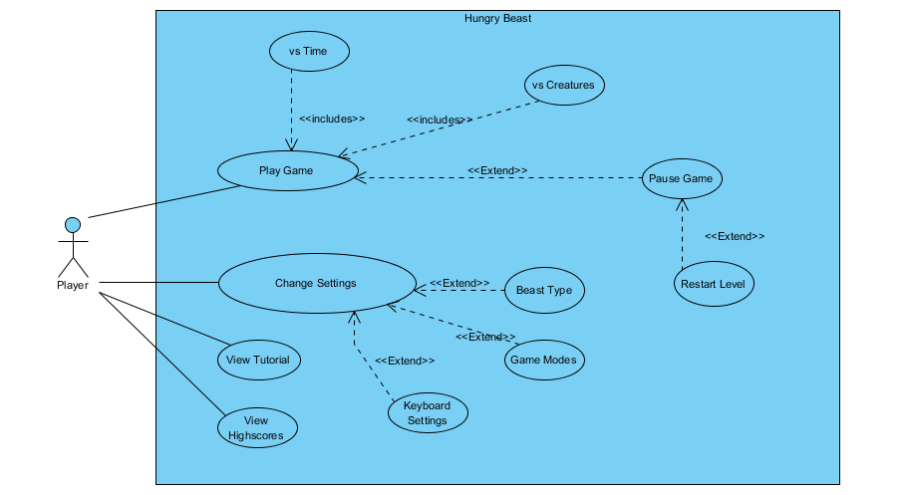

*Figure 1: Shows the use-case diagram of the Hungry Beast.*

2.7 User Interface

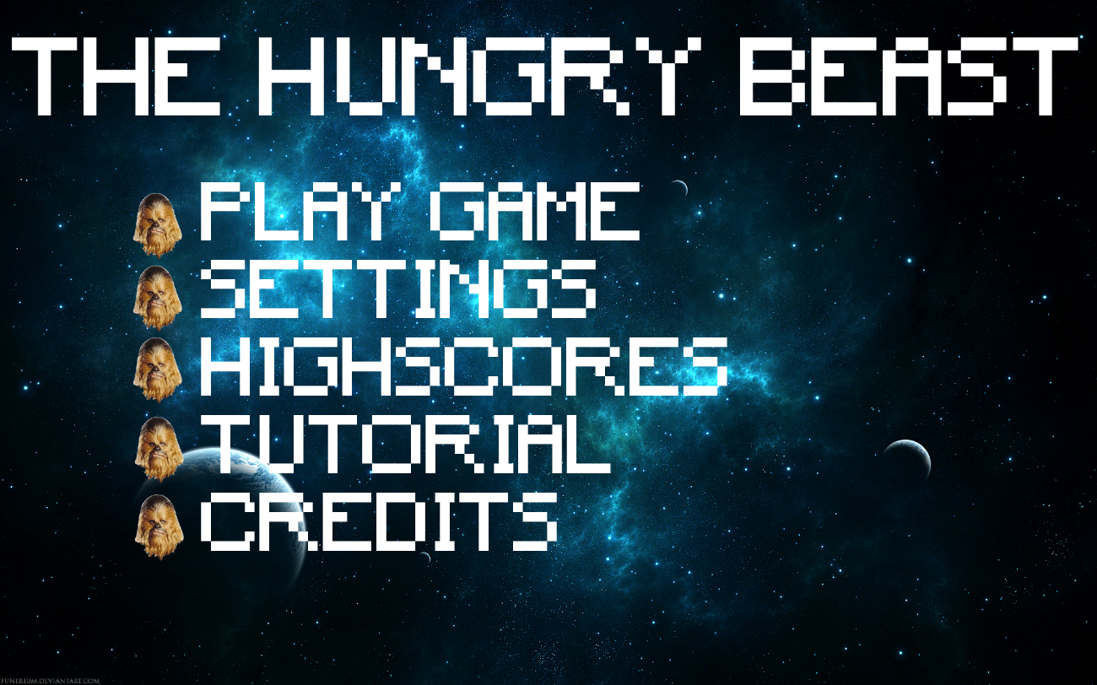

*Figure 2: Shows the main menu of our game.*

Main menu is the first screen that shows to the player. In main menu, player can start the game and choose the game mode or view high scores, Credits, Settings and Tutorial from here.

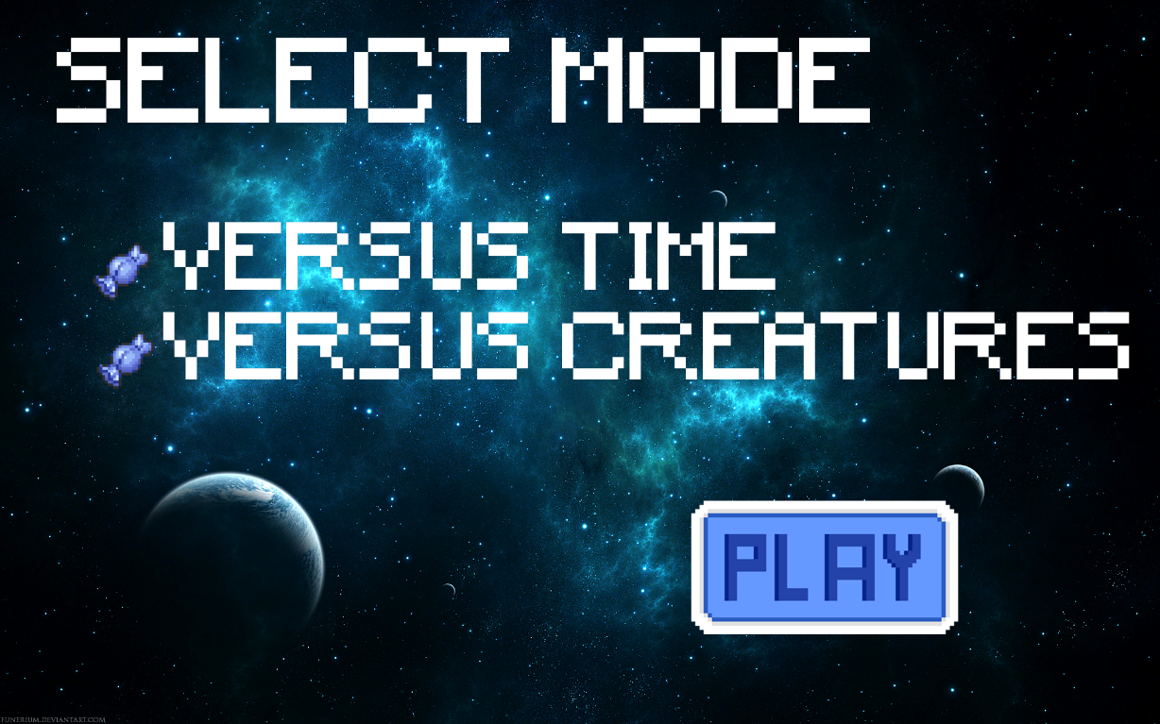

*Figure 3: Shows the screen after choosing play game button.*

Player can choose among from two modes. After clicking the mode that he/she wishes to play, he/she must click Play button for to start the game.

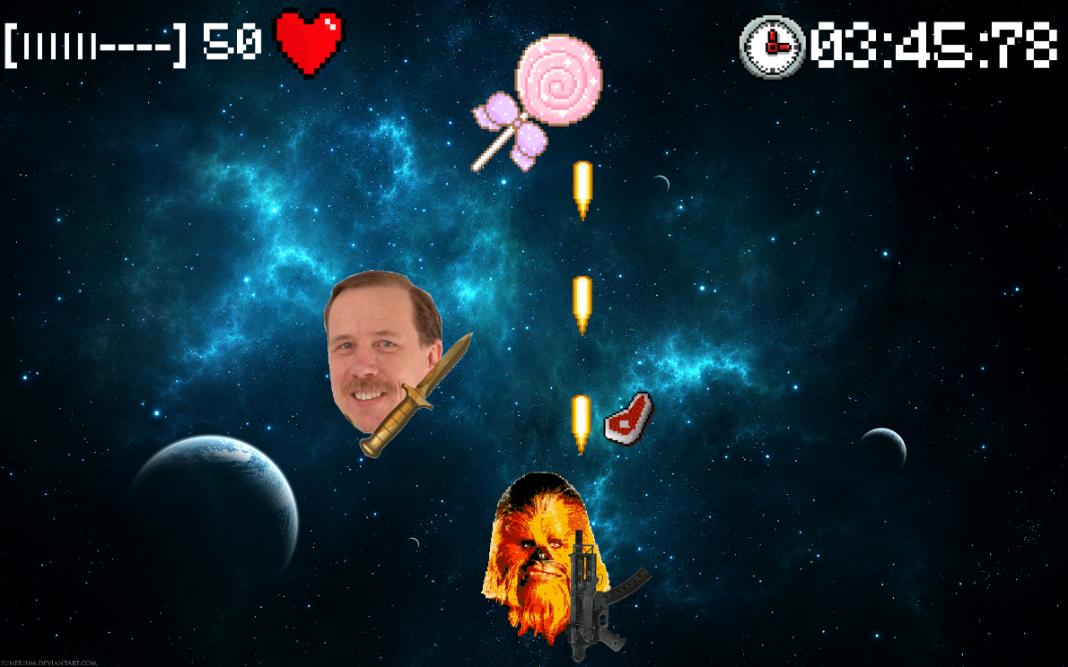

*Figure 4: Shows the gameplay of the Hungry Beast.*

This is a gameplay screen capture of vs Creatures mode. Hungry beast is shooting with its weapon. In the same time random food and creature object are dropping. Health and timer can be seen from the above.

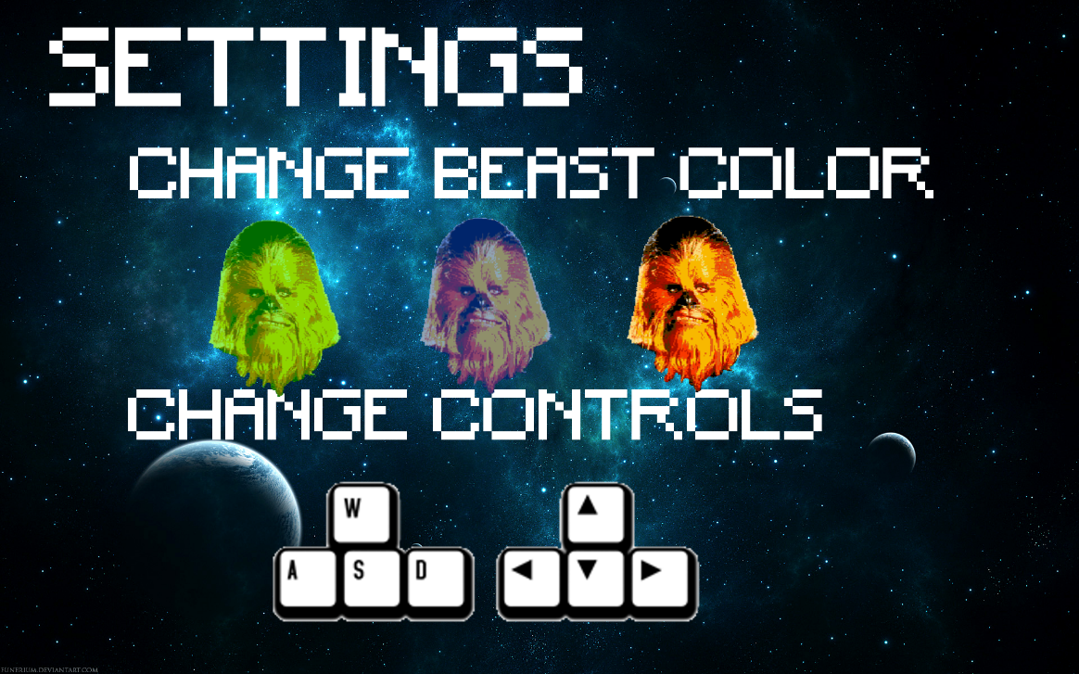

*Figure 5: Shows the change settings screen.*

From the change settings screen that can be reached from both during gameplay and main menu, there are three selectable different beast types. Each one has a different weapon. Game mods and keyboard settings can be adjusted from here too. 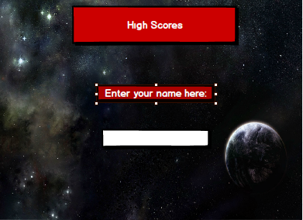

*Figure 6: Shows the high scores name entering screen.*

After playing and finishing any game mod, if player’s high score is high enough to enter the high score table, system will ask a name from the player. Player can enter his name from here. This page will be directed to high scores table.

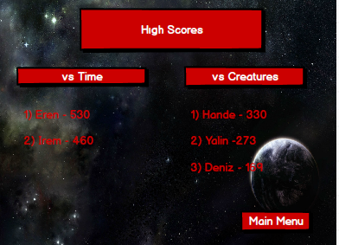

*Figure 7: Shows the high scores table with the corresponding game mode.*

After entering the name, user will be directed to high scores table. Each game modes has its own high score part for keeping the track of records. Using can return to main menu by clicking the main menu button.

If the user wants to learn about the game before starting to play, he can click ‘Tutorial’ button from the main menu and be directed to Tutorial screen. In this screen, user can find some information about the general logic and the objects of the game.

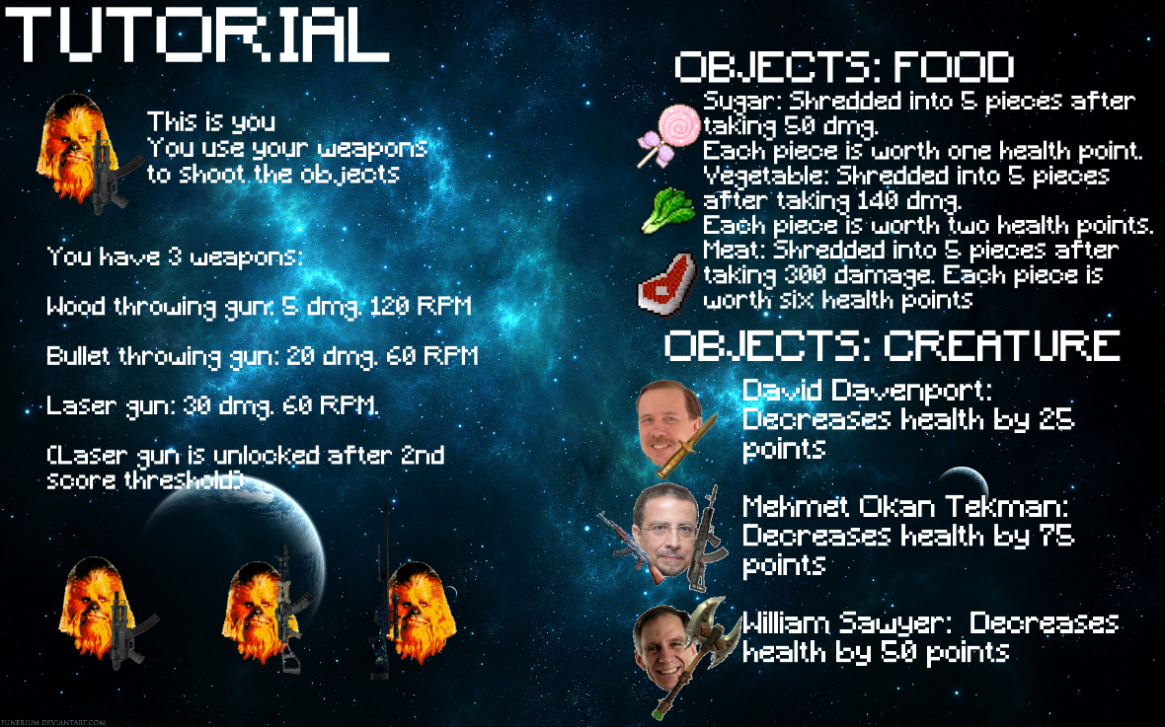

*Figure 8: Shows the tutorial screen*

Also, credits can be found in the main menu. User can press the ‘Credits’ button and be directed to Credits screen. In this screen, some information can be found about the people who contributed to the development of the application.

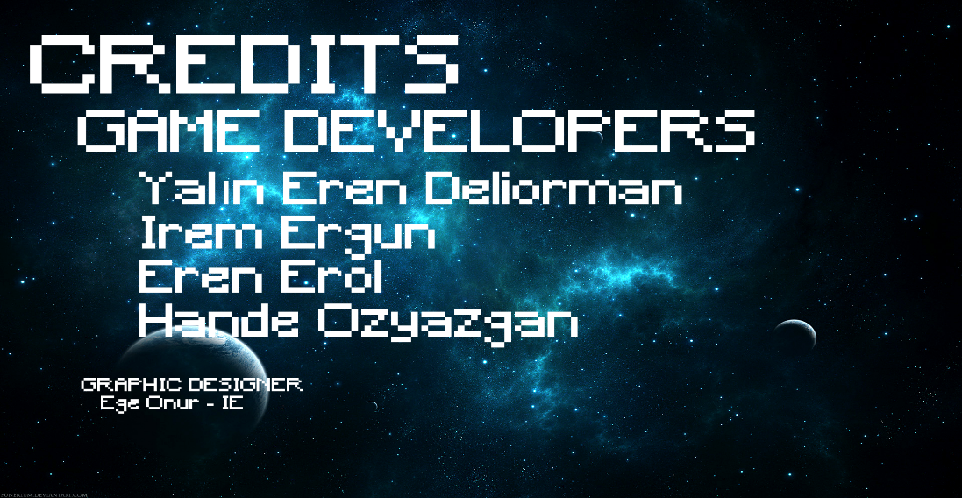

*Figure 9: Shows the credits screen*

Foods: These are the three different food types that will appear during gameplay. First one is sugar, second is meat and the third one is vegetable. All of them has different attributes as it is mentioned before.





*Figure 10: Shows the food types in the game.*

Creatures: These creatures will only appear in vs Creature mod. Each of them is reducing amount of health points from the beast. They are invulnerable.





*Figure 11: Shows the creatures in the game.*

# 3. Analysis

The domain lexicon, class diagram, state chart diagram and sequence diagrams are covered in this part.

# 3.1 Object Model

# 3.1.1 Domain Lexicon

Beast: This is an entity class for the user who plays the game. In the game, user directs the beast and tries to shoot foods above it. While the user is choosing the beast, he/she can change its color. Additionally, each beast has health attribute and either or not game is over will be decided based on its health.

Food: This class is an entity which reflects the real foods in the game. When the user manages to shred food, food will be split into number of pieces. Each food has health and when the food is split, each piece has also health according the number of pieces. There will be some kind of foods, such as sugar, vegetable and meat. Therefore, this is an environment that consisted of other entities like Sugar, Vegetable and Meat.

Creature: This class is an entity which affects the beast’s health negatively. In order to make the game a little bit difficult, there should be some creatures, some of which are DavidDavenport, WilliamSawyer and OkanTekman. Each creature negatively affects the beast’s health differently.

Weapon: This class is an entity for real weapons. In order to decrease foods’ health and split those into pieces user should use weapons. There will be cooldown so that user cannot shoot continually. There will be three different weapons some of which are Wood, Bullet and Laser. In terms of damage given by weapons, they are grouped like that. User plays the game with wood firstly, then, when user gets ahead in the game, he/she will be able to use bullet and laser.

# 3.1.2 Class Diagram

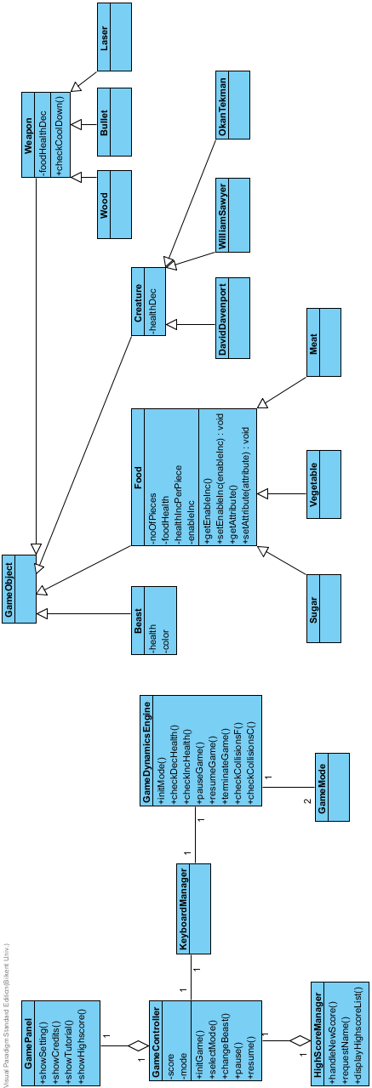

*Figure 12: Shows the class diagram of the Hungry Beast.*

In our design we have 20 classes. GamePanel class handles the GUI part of the program. GamePanel is interacting with the GameController class which is responsible initializing the game, selecting mode, changing the beast and resume/pause the game. It also have score and mode as properties to keep track of them. GameController class is related to HighScoreManager and KeyboardManager. HighScoreManager keep the track of high scores and the owner of these high scores. KeyboardManager is interacting with the GameDynamicsEngine class which is responsible for the fundamentals of the game. These are checking the collision between food and beast (checkCollisionsF()) also between beast and creature (checkCollisionsC()). There are methods also for controlling checking the changes in beast’s health, which are checkDecHealth() or checkIncHealth(). GameDynamicsEngine is related with 2 GameMode classes, vs Time and vs Creatures modes.

The remaining classes are all related with the GameObject class. Beast, Food, Creature and Weapon classes are inheritably combined with the GameObject class as children. Beast class has health and color as its properties. Food Class has three children which are Sugar, Vegetable and Meat classes. After foodHealth is 0, setEnableInc(enableInc) method will be true. This allows food to shred into noOfPieces. Each different type of food will give different healthIncPerPiece. Creature class has DavidDavenport, WilliamSawyer and OkanTekman classes as children. These creatures only have healtDec property which will differ by class. Weapon class has foodHealthDec property and checkCoolDown() method. Wood, Bullet and Laser which are 3 children of Weapon class will have different cooldown times and different food health decreasing amounts.

# 3.2 Dynamic Models

Dynamic models part have state chart diagram of the Hungry Beast and three different sequence diagrams which are responsible for showing two different game modes and firing a weapon.

# 3.2.1 State Chart

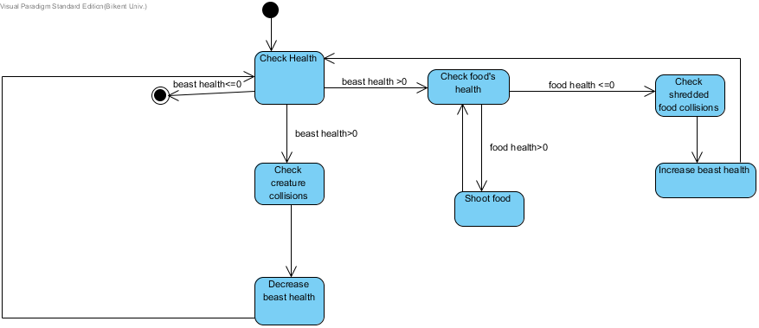

*Figure 13: Shows the state chart diagram of the Hungry Beast.*

There is only one condition to stop the game which is beast’s health is less than or equal to 0. If beast’s health is more than 0, user can continue to play.

There are 2 events that decrease or increase the health of the beast. Beast’s health can increase by the shredded food collision between beast and shredded food.

In order to obtain shredded food, user must shoot to food. If food’s health is less than or equal to 0, system will check whether shredded food collision happened or not. If it happened, it will increase beast health. If it is not happened, food will disappear when it touches to ground.

If fallen creatures collide with the beast, it will decreases its life. If beast’s health is less than or equal to 0 game will be terminated.

# 3.2.2 Sequence Diagram

Playing in vs Creatures mode: Player wants to play vs Creature mode in Hungry Beast. Firstly, he/she views available modes in the game. He/she chooses vs Creatures mode. System selects the mode and initialize mode and beast. The game mode will appear in the screen after playing the play button. Beast’s weapon is initialized. After the game starts food will randomly drop. For every destroyed Food object beast will gain health. After 30 seconds in the game, Creature objects starts to fall from above in random time intervals. After the game is finished, player’s high score is checked whether it is qualified enough to enter the high score table. In this scenario it is enough. System asks a name from the user. After entering the name, system shows high score table to player.

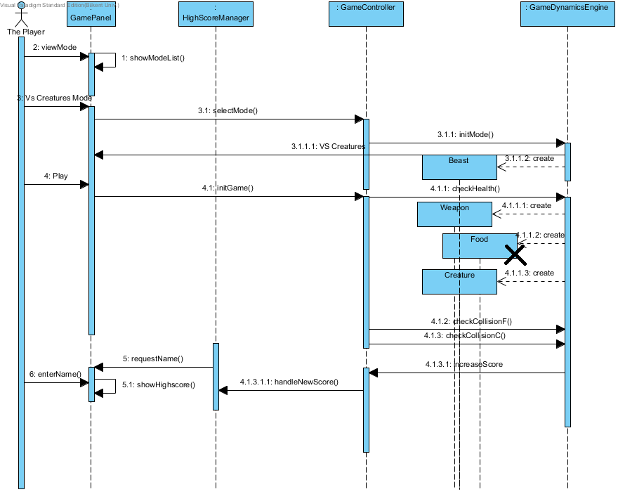

*Figure 14: Shows a scenario for game mode vs Creatures.*

Playing in vs Time Mode: Player wants to play vs Time modes in Hungry Beast. Firstly, he/she views available modes in the game. He/she chooses vs Time mode. System selects the mode and initialize mode and beast. The game mode will appear in the screen after playing the play button. Beast’s weapon is initialized. After the game starts food will randomly drop. For every destroyed Food object beast will gain health. The only difference in this game mode from vs Creatures is there are no creatures that decreases life. Therefore, the game can only end, if player cannot eat enough food before its health drop to 0. In this scenario, player is qualified to enter the high score table too. System will ask for his/her name and will display on the high score table.

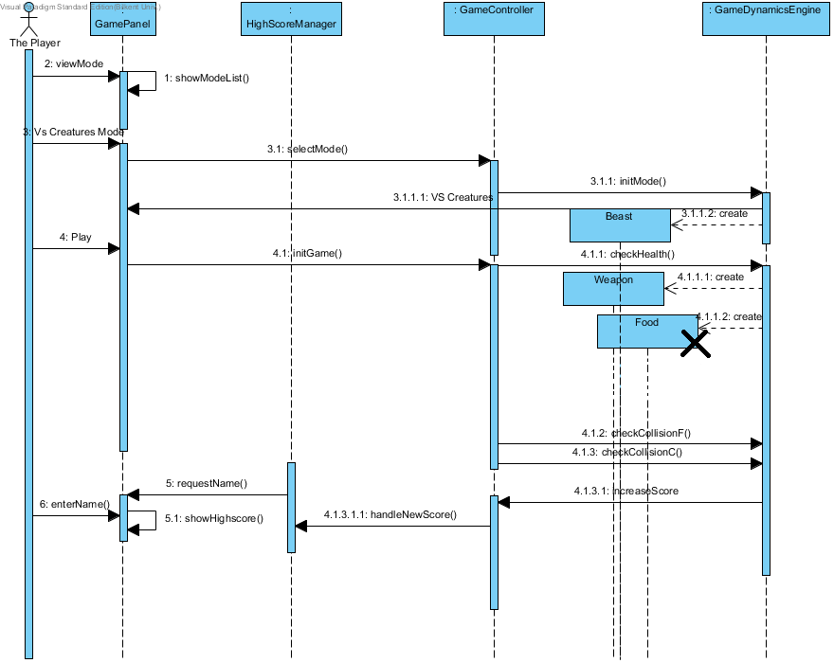

*Figure 15: Shows a scenario for game mode vs Time.*

Firing the Weapon: In this scenario, player wants to fire beast’s weapon. Firstly, he/she views available modes in the game. He/she chooses vs Creatures mode. System selects the mode and initialize mode and beast. The game mode will appear in the screen after playing the play button. Beast’s weapon is initialized. Until this part, it is same as the vs Creature mode. Player presses space for firing the weapon. It checks weapon cool down time. If it is available, weapon shoots again. If food’s health is less than or equal to 0, it will split in to pieces. When player cannot gather enough food, beast’s health will fall below 0 and game will finish. He/she enters his/her name for high score table.

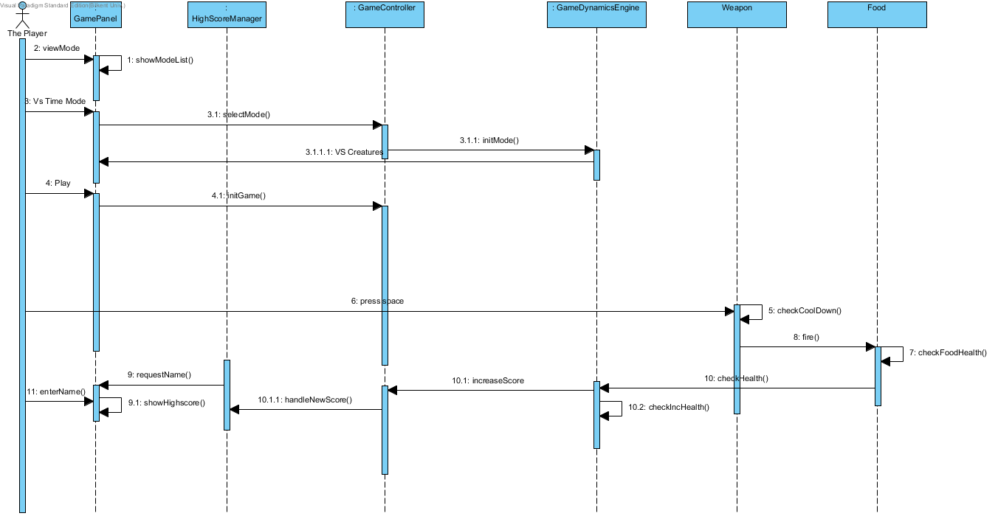

*Figure 16: Shows a scenario for firing the weapon.*

# 4. Conclusion

For a good analysis, this is the criterion that any other developer can understand this project and explanations without asking us anything about the project. Our goal is to present project analysis report which is totally comprehensible. In order to succeed it, it is needed to evaluate other's perspective, and check if they would follow our models and interpretations.